* 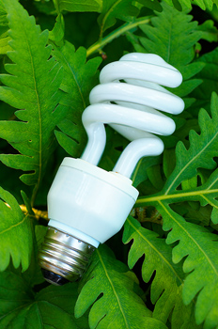[Recycling – Is It Worth It?](http://www.greenerideal.com/lifestyle/technology/1004recycling-is-it-worth-it/" \o "Permalink to Recycling – Is It Worth It?)

*by*[*Contributing Authors*](http://www.greenerideal.com/author/contributingauthors/)*• October 4, 2012 •*[*Green Technology*](http://www.greenerideal.com/lifestyle/technology/)*•*[*0 Comments*](http://www.greenerideal.com/lifestyle/technology/1004recycling-is-it-worth-it/#respond)

Most local authorities provide residents with containers in which they can sort and recycle their waste, as well as regularly collecting the recyclable material. It doesn’t take much effort to sort our waste into separate piles, and recycling seems a perfectly sensible thing to do in a world of finite resources. There are still some, [...]